**VISVESVARAYA TECHNOLOGICAL UNIVERSITY**



MINI PROJECT REPORT ON

**“RAIN WATER DETECTOR”**

SUBMITTED BY:

**C ABHINAY KUMAR REDDY- 1NH18EC026**

**G BHAVADEEP REDDY- 1NH18EC034**

**CHANDRA ROHITH– 1NH18EC025**

**BALAJI– 1NH18EC018**

Under the guidance of

**Ms.LIPSA DASH**

Senior assistant professor

Dept. of ECE, NHCE, Bengaluru.

# C:\Documents and Settings\Students\Local Settings\Temporary Internet Files\Content.Word\download (1).jpg

# NEW HORIZON COLLEGE OF ENGINEERING

(ISO-9001:2000 certified, Accredited by NAAC ‘A’, Autonomous college permanently affiliated to VTU)Outer Ring Road, Panathur Post, Near Marathalli, Bengaluru-560103

## NEW HORIZON COLLEGE OF ENGINEERING

## DEPARTMENT OF ELECTRONICS AND COMMUNICATION ENGINEERING



**CERTIFICATE**

Certified that the mini project work entitled “**RAIN WATER DETECTOR**” carried out by**C ABHINAYKUMARREDDY(1NH18ECO26),GBHAVADEEPREDDY(1NH18EC034),CHANDRAROHITH(1NH18EC025),BALAJI(1NH18EC018),** bonafide students of Electronics and Communication Department , New Horizon College of Engineering, Bangalore.

The mini project report has been approved as it satisfies the academic requirements in respect of mini project work prescribed for the said degree.

Project Guide HOD ECE

------------------------- -------------------------

**External Viva**

Name of Examiner Signature with Date

1.

2.

**ACKNOWLEDGEMENT**

The satisfaction that accompany the successful completion of any task would be, but impossible without the mention of the people who made it possible, whose constant guidance and encouragement helped us succeed.

We thank **Dr. Mohan Manghnani**, Chairman of **New Horizon Educational Institution**, for providing necessary infrastructure and creating good environment.

We also record here the constant encouragement and facilities extended to us by **Dr.Manjunatha**, Principal, NHCE and **Dr. Sanjeev Sharma**, head of the department of Electronics and Communication Engineering. We extend sincere gratitude to them.

We sincerely acknowledge the encouragement, timely help and guidance to us by our beloved guide **Ms.Lipsa Dash** to complete the project within stipulated time successfully.

Finally, a note of thanks to the teaching and non-teaching staff of electronics and communication department for their co-operation extended to us, who helped us directly or indirectly in this successful completion of mini project.

C ABHINAY KUMAR REDDY- 1NH18EC026

G BHAVADEEP REDDY- 1NH18EC034

CHANDRA ROHITH– 1NH18EC025

BALAJI– 1NH18EC018

**TABLE OF CONTENTS**

ABSTRACT

**CHAPTER 1**

INTRODUCTION…………………………………………………………………………………6

**CHAPTER 2**

LITERATURE SURVEY………………………………………………………………………… 7

**CHAPTER 3**

PROPOSED METHODOLOGY…………………………………………………………………..

**CHAPTER 4**

PROJECT DESCRIPTION ………………………………………………………………………..9

4.1 HARDWARE DESCRIPTION……………………………………………………………….10

**CHAPTER 5**

RESULTS AND DISCUSSION…………………………………………………………………13

**CHAPTER 6**

CONCLUSION AND FUTURE SCOPE …………………………………………………………14

REFERENCES…………………………………………………………………………………….14

APPENDIX………………………………………………………………………………………..

**LIST OF FIGURES**

|  |  |  |
| --- | --- | --- |
| **FIGURE**  **No** | **FIGURE DESCRIPTION** | **Page**  **No** |
| 1 | Circuit diagram of rain detector | 07 |
| 2 | Pin diagram Of IC555 timer | 09 |
| 3 | Transistor | 10 |
| 4 | LED | 10 |

### LIST OF TABLES

|  |  |  |  |
| --- | --- | --- | --- |
| **SL**  **No** | **Table**  **No** | **TABLE DESCRIPTION** | **Page**  **No** |
| 1 | 1 | Components used | 8 |
| 2 | 2 | Merits and Demerits | 11 |

ABSTRACT

Driver safety and comfort are the key objectives of the new trends in the automotive industry. An automatic wiper controller not only helps increase safety by reducing distractions, but also increases overall comfort. Such automatic control is available however, it has high cost and low efficiency limitations. In this work, we have proposed a windshield wiper automatic controller, based on a resistive rain sensor, cost-effective, efficient and offering a wide range of power. An almost identical mathematical and electrical model of the sensor is developed, simulated and verified. The rain sensor has a predetermined geometry. As a result, rainwater forms a film on the surface of the sensor, resulting in a non-linear change in its resistance. To increase the overall efficiency of the system, it is necessary to linearize the response of the sensor. It is performed using an equivalent electrical model of the sensor and an appropriate linearization circuit. In addition, a custom integrated system is developed using the PIC microcontroller to obtain a variation of the motor speed according to the output of the sensor. The proposed system is rigorously tested on a small car (Indica V2) for its performance. It is found that the developed system works satisfactorily under several rain scenarios.

1.INTRODUCTION

Water is very important resource in every one’s life, so proper usage and saving of water is necessary. RAIN WATER DTECTOR is a detector which detects the rain and automatically triggers the alarm and LED will be turned on,

So, here is the small attempt by our group to save rain water by implementing an initiative so that we can increase the underground water by using one of the technique of rain water harvesting.

Rain detector is a type of detector which detect the rain and make alert, rain detector is used in various applications like irrigation, communication, automobiles. so, here is the reliable circuit diagram of the rain detector that can be constructed at low of cost.

In this project we designed a simple rain detector circuit which depending upon the rain activates the buzzer, based on the buzzer necessary actions can be taken.

There are the three main components of the project rain sensor, IC 555 timer, Buzzer. The IC 555 timer is in A-stable mode configuration which turn on the buzzer.

The heart of the project is IC 555 timer. Rain Sensor, IC 555 timer, Buzzer are the onscreen heroes and transistors, diodes, resistors, capacitors are the offscreen heroes.

2. LITERATURE SURVEY

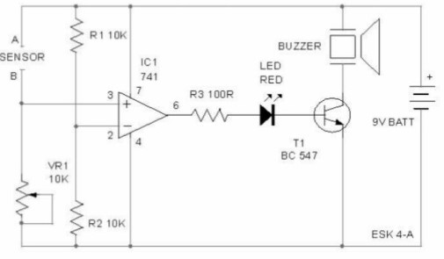

Components required

1.Rain sensor

2.connecting wires

3. bread board

4.9v battery

5.IC 741-Op Amp

6.Transistor -Bc 547

7.LED

8.10kohm resistor

9.100ohm resistor

10.buzzer

Working

1.In this above project they used Op-Amp 741 as a voltage comparator.

2.The half supplied voltage i.e 4.5 passes through resistors R1 and R2, connected to inverting pin2 of Op-Amp .its non-inverting input pin3 is connected to Rain Sensor and variable resistor R1.

3. Basically output of voltage comparator is high only when its pin2 gets a lower voltage than pin3.normally

Pin3 is low because there is no supply of current from the positive supply.so output remains low. This inhibits transistor T1 to act in cutoff region and buzzer remains off.

4.When the Rain Sensor is wet (rain), current passes through the contacts to the pin3 of the voltage comparator.

5.This higher voltage at pin3 causes the output to go high. LED lights and transistor act as a in saturation region (switch),buzzer then starts beeping to indicate rain.

3.PROPOSED METHODOLOGY

Block diagram of Rain Detector

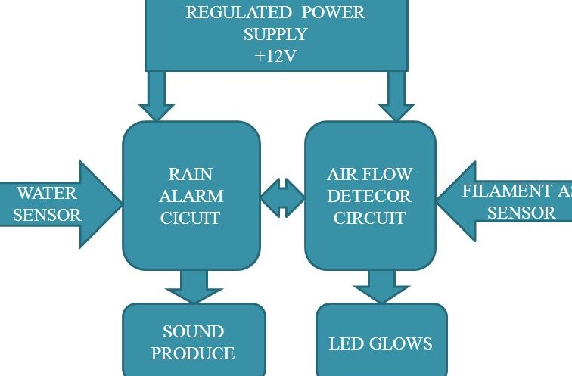

Circuit diagram

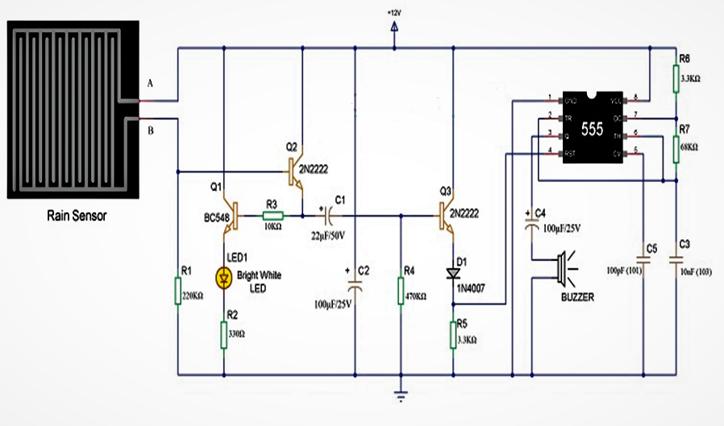

Working principle

1.when rain falls on the sensor, the Aluminum in the sensor starts conducting, the supply is given to the base of the transistor Q2.

2.As a result transistor Q2 will be turned on which in turn activate the transistor Q1, this will turn on LED which is connected to the emitter of the transistor Q1.

3.when the transistor Q2 reaches the saturation level the capacitor C1 is shorted and the transistor Q3 will be turned ON, capacitor C1 will be charged by resistor R4.

4.When the transistor Q3 reaches the saturation level, the reset pin will be made positive which is connected to reset pin of Q3 transistor.

5.The IC 555 timer is configured at A-stable mode.as the reset pin is given to positive voltage.it becomes active and pulse signal is generated at the output pin3 of IC 555 timer, this make the buzzer to activate.

6.capacitor C4, which is connected in between the pin3 and the buzzer, will block the DC signals and make allow only the variations in the signals which makes the buzzer to beep, therefore the diode act as forward bias.

7.Mostly due to resistor R4 and the capacitor C1 the buzzer starts beeping sound.

8. At sometime the capacitor is completely charged, the transistor Q3 will get in to cut-off region,

As a result, reset pin of IC 555 will not receive any voltage and buzzer stop making sounds.

9.When there is no rain, the aluminum wire on the sensor will not conduct (open circuit).As a result the IC 555 cannot trigger the signal and buzzer cannot sound.

4.COMPONENTS REQUIRED

|  |  |  |  |
| --- | --- | --- | --- |
| S. No | Required Components | Remarks | Quantity |
| 1 | Rain sensor |  | 1 |
| 2 | IC555TIMER |  | 1 |
| 3 | Transistor | BC548 NPN Transistor,2N2222 Transistor | 3 |
| 4 | Diode | 1N4007 | 1 |
| 5 | Resistor | Quarter watt | 68k ohm – 1  3.3K Ohm – 2  470k Ohm – 1  10K Ohm-1  330 Ohm-1  220k Ohm-1 |
| 6 | Capacitor | Ceramic and polarized | 22UF,100Uf polarized capacitor.10nF,100pF  Ceramic capacitor |
| 7 | LED | Colored | 1 |
| 8 | Power supply | 12v | 1 |

5.PROJECT DESCRIPTION

RAIN SENSOR

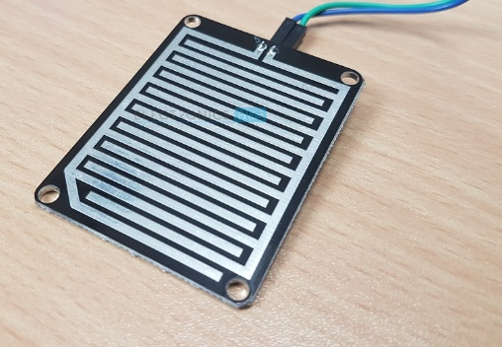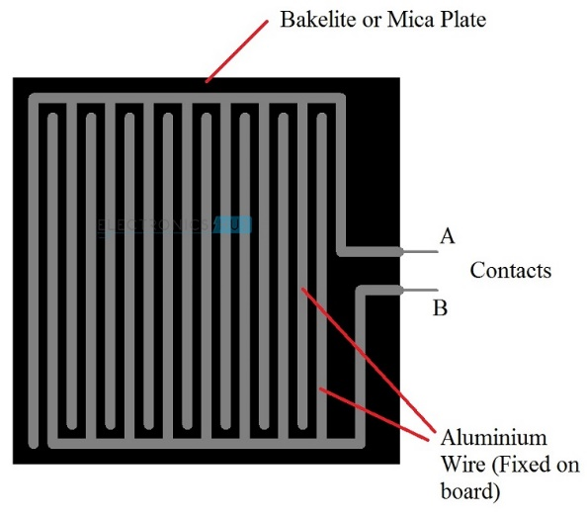

It is a simple sensor and an easy-to-use tool for detecting rain. It can act as a simple switch, where the switch is normally open and when it rains, it closes. Although the rainwater sensor is the main component of the circuit. We do not need to go shopping on the market or online. We can do it ourselves by taking the piece of bakelite plate or mica and the aluminum wire.

The bakelite or mica plate must be completely flat and the aluminum cable must be glued to the plate, as shown in the figure below. It must be ensured that there is no space between the cable and the card.

When the rainwater sensor is finished, it must be connected to the circuit and the voltage must pass through the wires. If it does not rain, the resistance between the contacts will be very high because there will be no conduction between the sensor wires.

If it rains, drops of water will fall on the rain sensor, which will form a conductive path between the wires and also reduce the resistance between the contacts.

As a result, the wires on the sensor board will drive and activate the NE555 timer through the transistor circuits. Once the NE555 is activated, the output pin will be high and the beep will activate the alarm.

IC555TIMER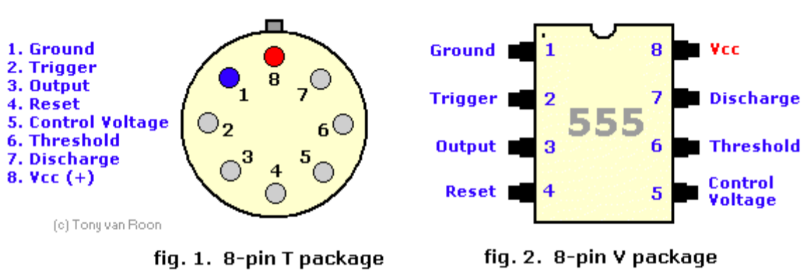

The timer IC 555 was introduced around 1971 by the company Signetics under the name SE555 / NE555 and was called "The Time Machine IC". It offered circuit designers a relatively inexpensive, stable and easy-to-use integrated circuit for monostable and astable applications. Since this device was first marketed, many unique and innovative circuits have been developed and presented in various commercial, professional and leisure publications. Over the past decade, some manufacturers have stopped making these timers for reasons of competition or other reasons. However, other companies, such as NTE (a sub-division of Philips) have resumed their activities where some have left.

Although the CMOS version of this IC, such as the Motorola MC1455, is primarily used, the standard type is still available, but many enhancements and variations have been made to the circuits. But all types are compatible with pin plugs. In this tutorial, the 555 timer is examined in detail, as are its uses, either alone or in combination with other semiconductor devices. This timer uses a labyrinth of transistors, diodes and resistors and, for this complex reason, a more simplified (but precise) block diagram is used to explain the internal organization of 555. The 555, in fig. 1 and FIG. 2 above, is available in two cases, either the round metal housing called "T", or the 8-pin DIP housing better known, "V". About 20 years ago, the type of canister was almost standard (SE / NE types). The 556 timer is a 555 dual version and comes in a 14-pin DIP package, the 558 is a quad version with four 555s also in a 14-pin DIP package.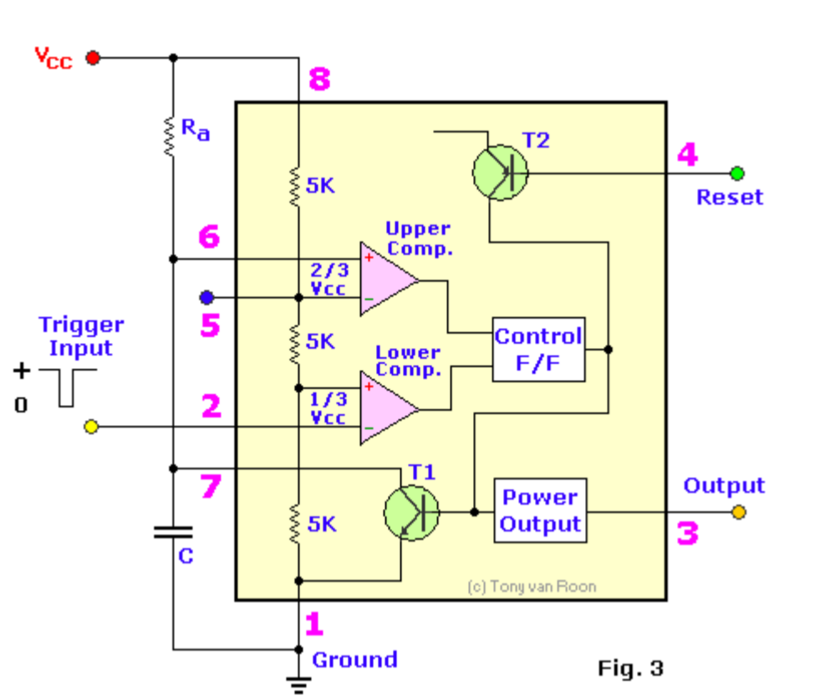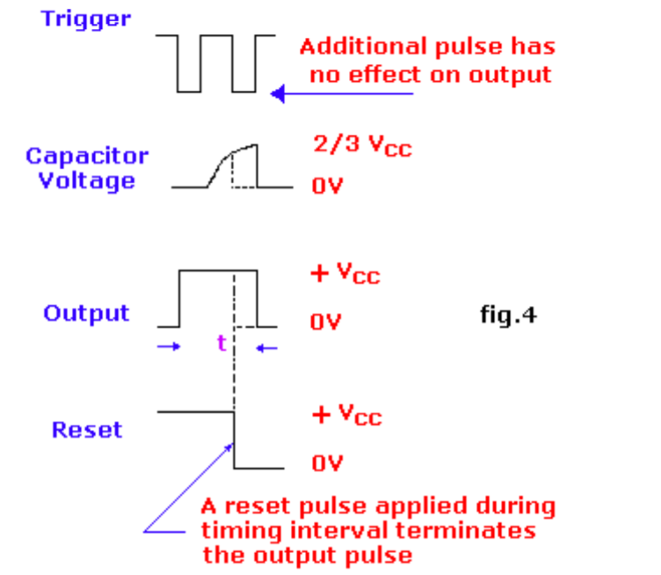

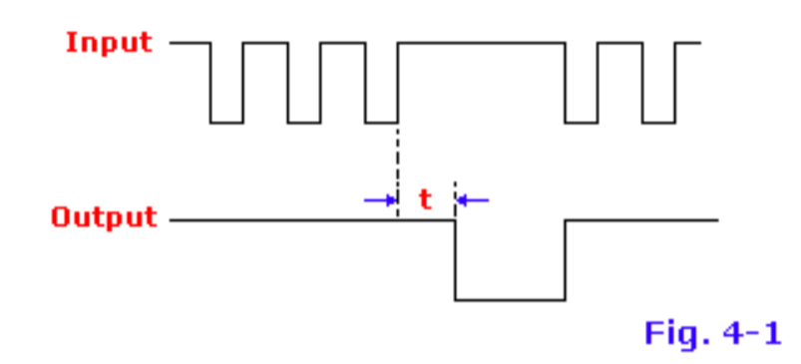

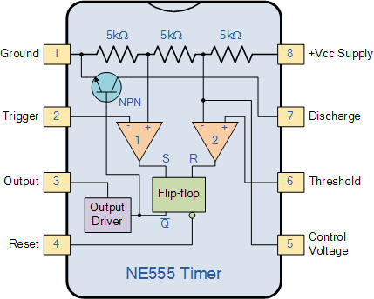

Definition of Pin Functions:

Pin 1 (ground): The ground (or common) pin is the most negative power potential of the device, which is normally connected to the common (ground) circuit when operating from positive supply voltages.

Pin 2 (trigger): This pin is the input of the lower comparator and is used to adjust the latch, which makes the output high. This is the beginning of the time sequence in the monostable operation. The shot is obtained by taking the pin up and down with a voltage of 1/3 V + (or, in general, half of the voltage appearing on pin 5). The action of the activation input is level sensitive, allowing the use of slow change rate waveforms, as well as pulses, as activation sources. The trigger pulse must be shorter than the time interval determined by external R & C. If this pin remains low longer, the output will remain high until the trigger input increases again. A caution to observe with the trigger input signal is that it should not be less than 1/3 V + for a longer period than the synchronization cycle. If allowed, the timer will be reactivated at the end of the first output pulse. Therefore, when the timer is used in monostable mode with input pulses longer than the desired output pulse width, the input trigger must be effectively shortened by differentiation. The minimum pulse width allowed for activation depends to some extent on the pulse level, but in general if greater than 1uS (micro-second), the activation will be reliable. A second precaution concerning the trigger input refers to the storage duration in the lower comparator. This part of the circuit may have normal stopping delays of several microseconds after activation; that is, the lock may still have an activation input during this period after the activation pulse. In practice, this means that the minimum monostable output pulse width must be of the order of 10 μS in order to avoid possible double activation due to this effect. The voltage range that can safely be applied to the trip pin is between V + and ground. A DC current, called the tripping current, must also flow from this terminal to the external circuit. This current is usually 500nA (nano-amp) and will set the upper limit of allowable resistance of pin 2 to earth. For an astable configuration operating at V + = 5 volts, this resistance is 3 megaohms; It can be higher for a higher level of V +.

Pin 3 (output): output 555 is from a high current totem stage consisting of transistors Q20 to Q24. Transistors Q21 and Q22 provide a drive for source-type loads, and their Darlington connection provides a high output voltage of about 1.7 volts less than the V + power level used. Transistor Q24 offers the possibility of absorbing the current for low state loads called V + (as typical TTL inputs). The transistor Q24 has a low saturation voltage, which allows it to interact directly with a good noise margin when it performs the current reduction logic. However, the exact output saturation levels vary considerably with the supply voltage, for both high and low states. At a V + of 5 volts, for example, the low state Vce (sat) is typically 0.25 volts at 5 mA. However, when running at 15 volts, it can absorb 200 mA if a 2 volt output voltage level is allowed (the power dissipation must be taken into account in this case, of course). The high state level is typically 3.3 volts at V + = 5 volts; 13.3 volts at V + = 15 volts. The rise and fall times of the output waveform are quite fast, the typical switching times are 100nS. The state of the output pin will always reflect the opposite of the logic state of the latch, which can be seen by examining FIG. 3. Since the lock itself is not directly accessible, this relation can be better explained in terms of the activation activation lock conditions. To activate the output in the high state, the activation input is momentarily taken from a higher level to a lower level. [see "Pin 2 - Trigger"]. This causes locking and high output. The performance of the lower comparator is the only way to set the output high. The output can return to a low state by raising the threshold from a lower level to a higher level [see "Pin 6 - Threshold"], which resets the latch. The output can also be reduced by bringing the reset to a low state near the ground [see "Pin 4 - Reset"]. The output voltage available on this pin is approximately equal to the Vcc applied to pin 8 minus 1.7Vs.

Pin 4 (reset): This pin is also used to reset the latch and return the output to a low state. The threshold level of the reset voltage is 0.7 volts and a 0.1 mA dissipation current of this pin is required to restart the device. These levels are relatively independent of the V + level of operation; Thus, the reset input is compatible with TTL for any supply voltage. The reset input is a primary function. that is, it will force the output to a low state regardless of the state of the other inputs. Therefore, it can be used to prematurely terminate an output pulse, to block oscillations from "on" to "off", etc. The delay time between the restart and the output is generally of the order of 0.5 μS and the minimum width of the reset pulse is 0.5 μS. However, none of these numbers are guaranteed and may vary from manufacturer to manufacturer. In summary, the reset pin is used to reset the latch that controls the state of output pin 3. The pin is activated when a voltage level between 0 and 0.4 volts is applied to the pin. The reset pin will force the output to a low level, regardless of the state in which the other inputs of the flip-flop are located. When not in use, it is recommended to connect the reset input to V + in order to avoid the possibility of false restart.

Pin 5 (control voltage): This pin allows direct access to the 2/3 V + voltage division point, the reference level of the upper comparator. It also allows indirect access to the lower comparator because there is a 2: 1 splitter (R8 - R9) from this point to the lower comparator reference input, Q13. The use of this terminal is a user option, but it allows extreme flexibility by allowing the modification of the period, the restart of the comparator, etc. When timer 555 is used in a voltage controlled mode, its voltage operation varies from about 1 volt less than V + to 2 volts of mass (although this is not guaranteed). Voltages may safely be applied outside these limits, but must be limited within the V + and ground limits for reasons of reliability. By applying a voltage to this pin, it is possible to vary the duration of the device independently of the RC network. The control voltage can vary from 45 to 90% of the Vcc in monostable mode, which allows the output pulse width to be controlled independently of RC. When used in astable mode, the control voltage can vary from 1.7 V to full VDC. Variable voltage in astable mode will produce a modulated frequency (FM) output. If the control voltage pin is not used, it is recommended to ground it with a capacitor of about 0.01uF (10nF) for noise immunity because it is an input comparison. This fact is not evident in many 555 circuits since I have seen many circuits with "no-pin-5" connected to anything, but this is the proper procedure. The small ceramic lid can eliminate false activations.

Pin 6 (threshold): Pin 6 is an input of the upper comparator (the other is pin 5) and is used to reset the latch, resulting in low output. The reset through this terminal is made by taking the bottom terminal to a voltage of 2/3 V + (the normal voltage on pin 5). The action of the threshold pin is level sensitive, which allows slow rate of change waveforms. The voltage range that can safely be applied to the threshold pin is between V + and ground. A direct current, called the current threshold, must also reach this terminal from the external circuit. This current is generally 0.1 μA and will define the upper limit of total resistance allowed from pin 6 to V +. For any synchronization setting that operates at V + = 5 volts, this resistance is 16 MΩ. For operation at 15 volts, the maximum resistance value is 20 MΩ.

Pin 7 (discharge): this pin is connected to the open collector of an NPN transistor (Q14), whose emitter is grounded, so that when the transistor is activated, pin 7 is actually short-circuited to the mass. Generally, the sync capacitor is connected between pin 7 and ground and is discharged when the transistor is turned on. The state of attack of this transistor has a synchronization identical to that of the output stage. It is "on" (low resistance to earth) when the output is low and "off" (high resistance to earth) when the output is high. In the monostable and astable time modes, this transistor switch is used to ground the appropriate nodes of the synchronization network. The saturation voltage is generally less than 100 mV (millivolts) for currents of 5 mA or less, and the leakage in the off state is approximately 20 nA (however, these parameters are not specified by all manufacturers) . The maximum collector current is internally limited by design, thus eliminating capacitor size restrictions due to the maximum discharge of the pulse current. In some applications, this open-collector output can be used as an auxiliary output terminal, with a current-dissipating capacity similar to that of the output (pin 3).

Pin 8 (V +): Pin V + (also called Vcc) is the positive power supply terminal of the timer CI 555. The operating voltage supply range of the 555 is between +4.5 volts (minimum) and +16 volts (maximum). It is specified for operation between +5 volts and +15 volts. The device will operate essentially in the same way in this voltage range without changing the period. In fact, the most significant operating difference is the capacity of the output inverter, which increases for both the current and voltage ranges as the supply voltage increases. The sensitivity of the time interval to the variation of the supply voltage is low, typically 0.1% per volt. T here are special and military devices operating at voltages up to 18 V.

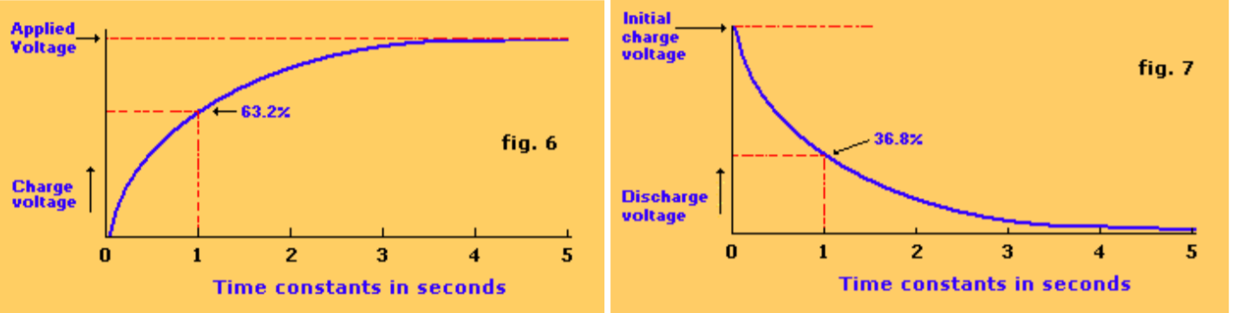

**555 Timer Bi-stable**

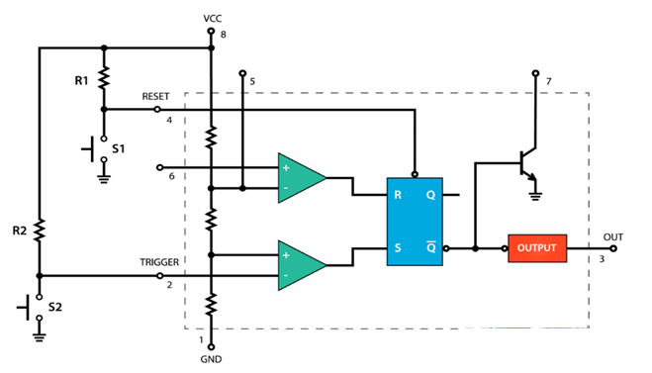

Fig.8

Let's look at an example of the 555 timer running in bi-stable mode. For this, we need two external resistors and two buttons.

The reset and reset pins of the integrated circuit are connected to VCC via the two resistors and are thus always high. Both buttons are connected between these pins and the ground. Therefore, if you hold them down, the input state will be low.

Initially, the two outputs of the comparators are 0, therefore, the output of the flip-flop and the output of the timer 555 are 0.

If we press the Trigger button, the state of the Trigger input becomes Low. The comparator emits a High signal, which causes an output of the low level of the Q bar of the reversal. The exit step will reverse this trend and the final output of the 555 timer will be high.

The output will remain high even if the trigger is not depressed because, in this case, the inputs of the R and S flip-flops will be at 0, which means that the flip-flop will not change the previous state. To make the output low, we have to press the reset button, which resets j and k flip-flops the entire integrated circuit.

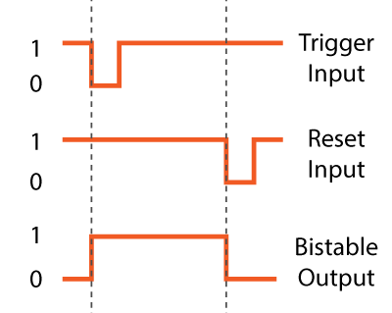

**555 Timer – Monostable Mode**

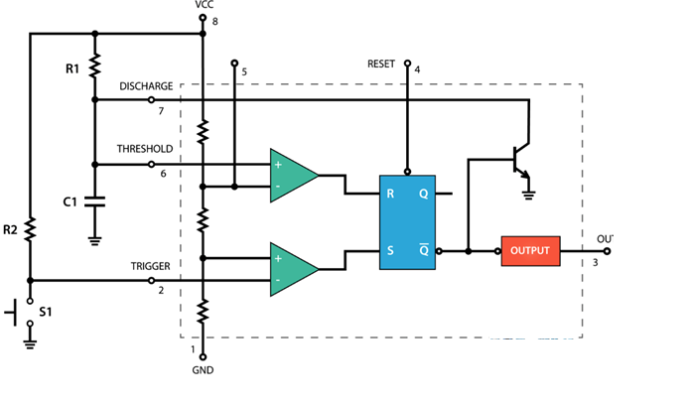

**Fig 9**

Next, let's see how the 555 timer works in monostable mode. Here is an example of a circuit.

The trigger input is held high by connecting it to VCC via a resistor. This means that the trigger comparator will generate 0 at the S input of the flip-flop. On the other hand, the threshold pin is low and the threshold comparator is also equal to 0. The threshold pin is really low because the Q bar output of the flip-flop is high, which keeps the transistor active. discharge, so that the voltage that comes from the source will be grounded through this transistor.

To change the output status of the 555 timer to the high position, press the trigger pin button. This will set the activation pin to earth or the state of the input will be 0, so the comparator will send 1 to the S input of the flip-flop. This will reduce the output of the Q bar and the output of the timer 555. At the same time, we can note that the discharge transistor is off, so that the capacitor C1 will now start charging through the resistor R1.

The timer 555 will remain in this state until the voltage across the capacitor reaches 2/3 of the supplied voltage. In this case, the threshold input voltage will be higher and the comparator will send 1 to the input R of the flip-flop. This will bring the circuit to the initial state. The output of the Q bar will become high, which will activate the discharge transistor and will also cause the output of the integrated circuit.

Then, we can note that the time during which the output of the timer 555 is high depends on the time required for the capacitor to charge at 2/3 of the voltage supplied, and this depends on the values ​​of the capacitor C1 and the resistor R1. In fact, we can calculate this time with the

# following formula

# 555 Timer – Astable Mode

# Let's see how the 555 timer works in stable mode. In this mode, the integrated circuit becomes an oscillator or even called Free Running Multi vibrator. It has no stable state and continuously switches between High and Low without applying an external trigger. Here is an example of a 555 timer circuit running in stable mode.

# We only need two resistors and one capacitor. The trigger and threshold pins are connected to each other. No external trigger pulse is needed. Initially, the voltage source will begin charging the capacitor through the resistors R1 and R2. During charging of the tripping comparator, 1 is output because the input voltage on the tripping pin is always less than 1/3 of the supplied voltage. This means that the output Q bar is 0 and the discharge transistor is closed. At this point, the performance of the 555 timer is high.

# R1.put low again.

# 

Once the voltage at the terminals of the capacitor reaches 1/3 of the supplied voltage, the tripping comparator emits 0, but at this stage, it undergoes no modification, the inputs R and S of the flip-flops being equal to 0. The voltage Through the capacitor, it will continue to increase and once it has reached 2/3 of the supplied voltage, the threshold comparator will emit 1 to the R input of the flip-flop. This will activate the discharge transistor and the capacitor will now begin to discharge via resistor R2 and the discharge transistor. At this time, the output of the 555 Timer is low.

During the discharge, the voltage across the capacitor begins to decrease and the threshold comparator starts immediately at the output 0, which makes no change, since the inputs R and S of the flip-flop are now zero. Once the voltage across the capacitor drops to 1/3 of the supplied voltage, the trigger comparator emits 1. This turns off the discharge transistor and the capacitor starts charging again. Therefore, this process of charging and discharging between 2/3 and 1/3 of the supplied voltage will continue to operate on its own, producing a square wave at the output of the timer 555.

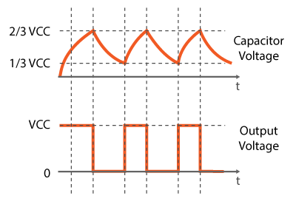

RESISTORS:

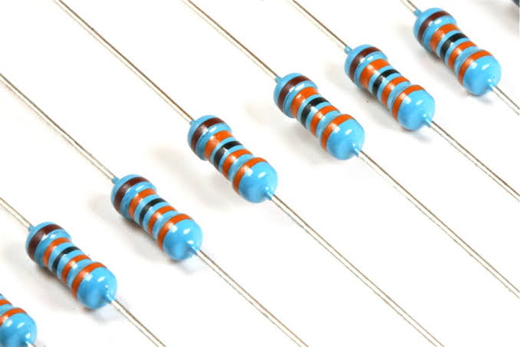

Resistance is a passive electrical component intended to create resistance in the flow of electric current. In almost all electrical networks and electronic circuits can be found. The resistance is measured in ohms. An ohm is the resistance that occurs when a current of an ampere passes through a resistor with a drop of one volt between its terminals. The current is proportional to the voltage at the ends of the terminal. This relationship is represented by Ohm's law:

formula with ohm law: R = V / I

Resistors are used for many purposes. Some examples include electrical current delineation, voltage division, heat generation, matching and load circuits, control gain, and fixed time constants. They are commercially available with resistance values ​​in a range of more than nine orders of magnitude. They can be used as electrical brakes to dissipate the kinetic energy of trains or be less than one millimeter squared for electronics.

CAPACITORS:

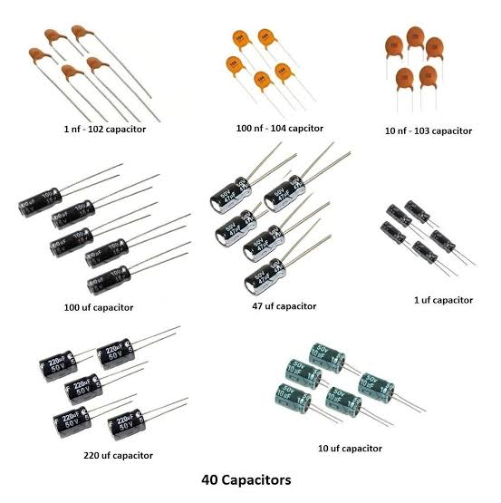

A capacitor is a two-component electrical component used to store electrostatic energy. Unlike a resistor, a capacitor does not dissipate energy. Instead, a capacitor stores energy. When a potential difference is created between the conductors, an electric field develops through the dielectric, which causes the charge of a positive charge (+ Q) on a plate and its charge. negative charge (-Q) on the other board. If a battery has been connected to a capacitor for a sufficient period of time, the current can not flow through the capacitor. However, an AC voltage is applied to the capacitor leads, a displacement current can flow.

An ideal capacitor is given by a single constant value for its capacitance. The capacitance is expressed by the relationship between the electric charge (Q) in the conductor and the potential difference (V) between them. The SI unit is FARADIUM (F), which corresponds to a coulomb per volt (1 C / V). Typical capacities range from about 1 pF (10-12 F) to 1 mF (10-3 F).

POWER SUPPLY:

A power supply is a device that supplies electric power to a electric load. the term is most commonly referred to electric power converts that converts one form of electrical energy to another, though it may also refers to that convert another form of energy ( mechanical chemical, solar) to electrical energy . The regulated power supply is that controls the output voltage or current to a specific value; the controlled value is held nearly.

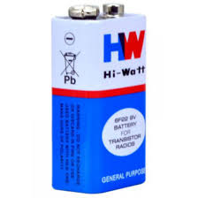

DIODE:

The diode, an electrical component that allows the current to flow in one direction. In circuit diagrams, a diode is represented by a triangle with a line passing through a vertex. The most common type of diode uses a junction p n. In this type of diode, a material (n) in which the electrons are charge carriers is based on a second material (p) in which the holes (depleted positions of the electrons playing the role of positively charged particles) serve as load carriers on its own. interface, a depletion region is formed through which the electrons diffuse to fill the holes on the p side. This stops the extra flow of electrons. When this junction is forward biased (i.e. a positive voltage is applied on the p side), the electrons can easily move in the junction to fill the holes and a current flows in the diode . When the junction is reverse biased (i.e. a negative voltage is applied on the p side), the depletion region widens and the electrons can not move easily. The current remains very low until it reaches a certain voltage (the cut-off voltage) and the current suddenly increases.

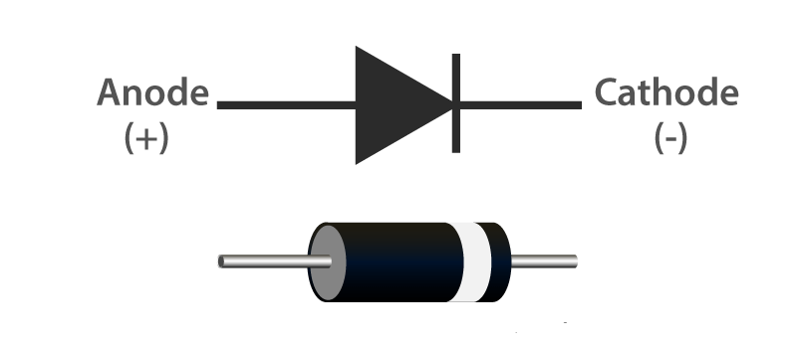

BUZZER:

A buzzer is a small but effective component to add sound functions to the circuit. buzzer is a very compact and small 2-pin structure. it can be easily used component in most electronic applications.

There are two types of buzzers commonly available. The first type is a simple buzzer that, once activated, will produce a continuous Beep sound. the other type is known a ready-to-use buzzer that looks bigger and will beep. Beep Sound is due to internal oscillating circuit present inside. But the one we used in the rain detector is the most used because it can be customized using other circuits to easily adapt to our application.

This buzzer can simply be used when DC power source ranging from 4V to 9V. A single 9V battery can also be used, but it is recommended to use a regulated power supply of + 5V or + 6V DC. The sound is normally associated with a switching circuit to activate or deactivate the sound at the required time and interval.

BUZZER PIN CONFIGURATION

|  |  |  |
| --- | --- | --- |
| **Pin Number** | **Pin Name** | **Description** |
| 1 | Positive | Identified by (+) symbol or longer terminal lead. Can be powered by 6V DC |
| 2 | Negative | Identified by short terminal lead. Typically connected to the ground of the circuit |

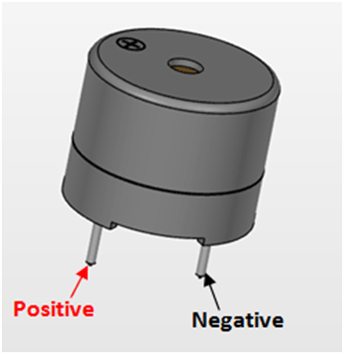

Transistor

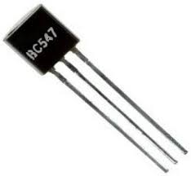

BC547 is an NPN- transistor normally transistor can be used in two ways for amplification and switch. In this project we commonly used it as switch to amplify the current the transistor should be in active region. The closed switch and open switch conditions can be achieved when the transistor is in saturation (or) cut of region.

BC547 is a common emitter configuration for amplifier for switching application the working of transistor depends on its base signal.

LED

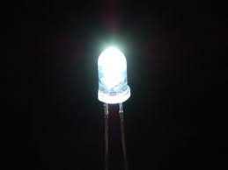

Light Emitting Diode (LED) is a light source that resembles a p-n junction diode.

When the positive current is more than the anode side than the cathode part. Electrons will recombine with holes, during this process there will be release of energy in the form of photons. This phenomenon is known as Electroluminescence and color depends of energy band gap of semiconductor.

BREAD BOARD

A bread board is a solderless device for temporary prototypes with electronic circuit designs and tests. Most electronic components in electronic circuits can be interconnected by inserting their wires or terminals into the holes and then making wire connections where appropriate.

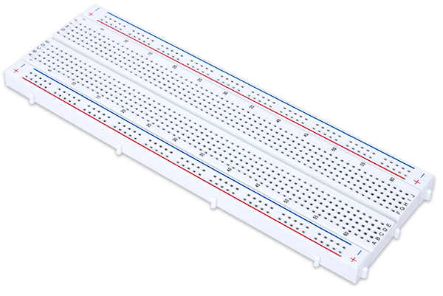

6.APPLICATIONS

In irrigation, it will detect the rain and immediately alert the farmer.

In cars, when the rain sensor detects rain, it immediately activates the windshield wipers and informs the driver.

In communications, the power of the antenna will increase and the signal strength to send or receive signals will increase.

In the normal house, using the rain sensor, we can automatically save rainwater. (This can only be done when home automation is complete and the necessary equipment saves rainwater. the rain sensor will detect rain and help turn on the equipment that will automatically save rainwater fine different).

This can also be used if there is also chemical rain. This is very common in industrial areas.

7.CONCLUSION

The alarm and rainwater detection system will be Useful in domestic and industrial applications. Alert the user (s) to the presence of rain during it's about to rain, even the smallest drops of water trigger the circuit, which gives the user enough time to recover his belongings, close the windows and Some cases are ready to harvest rainwater. The device when properly placed to receive the first set of raindrops can save the harmful goods that were drying in the sun / prevent rain from entering homes, offices.

8.FUTURE SCOPE

The future scope of this project is to increase the application of such circuits using the IC 555 for an easy lifestyle. These rain detection circuits can be used for many future purposes, such as collecting rainwater, etc. this project can be done in a similar way using Arduino. This will help us in addition to other alarm functions circuit and everything will be automated.

9.REFERENCES

* Mukul Joshi; Kaustubh Jogalekhar; Vinayak Sagare; M.A joshi
* **published in:**[2013 Seventh International Conference on Sensing Technology (ICST)](https://ieeexplore.ieee.org/xpl/conhome/6698448/proceeding)
* [www.electronishub.org](http://www.electronishub.org)
* /www.slideshare.net/BhavikVashi1/basic-electronicsrain-alarm
* Wikipedia, rain sensor
* Modern digital electronics: R.P JAIN
* Ashik K.P, A.N. Basanaraju” Automatic wipers with mist control”, American Journal of Engineeing Research(AJER), Vol. 03, Issue 04, Page 24-34.